

Talk – Thursday, 8:30 AM
Brain structure provides the key to unraveling the function of bizarre dinosaur crests.
New study uses high-tech imaging to explore inner structure of dinosaur skulls

David C. Evans. Dept. of Natural History, Royal Ontario Museum, Toronto, Ontario, Canada.

Lawrence M. Witmer. Dept. of Biomedical Sciences, Ohio University, Athens, OH

Ryan C. Ridgely. Dept. of Biomedical Sciences, Ohio University, Athens, OH

John R. Horner. Museum of the Rockies, Montana State University, Bozeman, Montana

The strange bony crests found in the skulls of the duck-billed dinosaurs known as lambeosaurs come in a variety of sizes and shapes, even in closely related species. These crests contain incredibly long, convoluted nasal passages that loop up over the tops of their skulls. Without any modern animal with similar structures, paleontologists have long debated the function of the crests. A new study led by David Evans, a paleontologist at the Royal Ontario Museum and the University of Toronto, used CT-scanning to look inside the passages and cavities in the skulls and reconstruct the brains and nasal cavities of four different lambeosaur species. “The shape of the brain can tell us a lot about what senses were important in a dinosaur’s everyday life, and give insight into the function of the crests” said Evans.
Paleontologists have debated the function of lambeosaur crests since the 1920s. Some suggested that they heightened the sense of smell by increasing the surface area of the sensory tissue, others that they functioned in temperature regulation, and still others that the crests acted as sound resonators for communication. “It’s difficult to infer the function of structures in an extinct dinosaur when there is so little resemblance to any living animal,” said Jack Horner, a member of the team and paleontologist at Montana State University. With the CT scans, Evans and his team were able to circumvent the problems of fossilization. “Even though the soft tissues are not preserved in the fossils, the shape of the bones that encase the brain and nasal passages are,” said Evans. “From there, the anatomy of these missing soft parts is easily interpreted.”
The CT scan results revealed a mismatch between the external shape of the crest (which no doubt functioned as a visual display) and the internal shape of the nasal passages in closely related species, suggesting a special function for the nasal cavity. The portion of the brain responsible for the sense of smell was relatively small and primitive, indicating that the crest did not evolve to improve the sense of smell. Computer models done by other researchers suggest that the crests could have been used to make low, eerie bellowing calls that could have been used in communication, perhaps to call for mates or warn others of predators. The CT scans documented a delicate inner ear that confirms that the dinosaurs could hear the low-frequency calls produced by the crest. “We were surprised to see just how large the centers of the brain associated with higher cognitive functions were”, said Lawrence Witmer of Ohio University who, along with Ryan Ridgely, performed the CT scanning and analysis. “We suspected that the crested duck-billed dinosaurs used both vocal and visual displays, but now we see that they had the brain power and hearing to pull off these behaviors,”
When all the available information is put together, including the digital brain and ear casts, the evolutionary relationships of the species, and the growth pattern of the crest and its high degree of variability in different co-existing species, it supports the idea that the elaborate nasal cavity was likely used to produce sounds for intraspecific communication. This study demonstrates the power of using an integrated approach combining 3D imaging, growth studies, and phylogenetic sampling to test ideas about the function and evolution of unusual structures in extinct animals.

This project was supported by grants from the National Science and Engineering Research Council of Canada (Evans) and the National Science Foundation (Witmer and Ridgely).

This work will be published in part in an upcoming issue of the journal The Anatomical Record.

David Evans can be contacted at: davide@rom.on.ca
Presentation Time: Thursday, October 16, 8:30 AM
People @ SVP who can comment: Larry Witmer, Ryan Ridgely, Jack Horner, Peter Dodson, David Weishampel

Note to media: High-resolution images and animations of the lambeosaurs can be viewed and downloaded here:
http://www.oucom.ohiou.edu/dbms-witmer/Media/SVP_dinosaur_media.htm
Case-sensitive login - username: svp-ou, password: Dino12

Images:

Fig 1. The diversity of crests in the lambeosaurine dinosaurs Parasaurolophus, Corythosaurus, and Lambeosaurus. Courtesy of Michael Skrepnick.
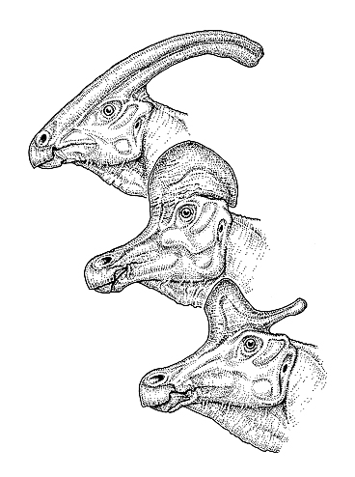

Fig 2. A life reconstruction of the helmet-crested lambeosaur Corythosaurus. Courtesy of Michael Skrepnick.

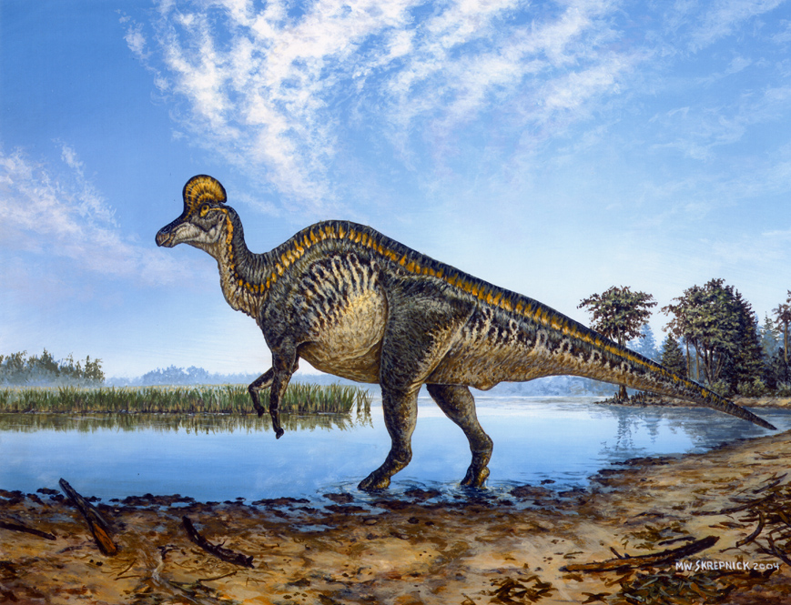

Fig. 3. Reconstructions of the skull in a juvenile and sub-adult Corythosaurus created using CT scanning. The nasal cavity is highlighted in green, and the brain appears in purple. Courtesy of Ohio University.


